Task 1:

**Task: Build a Modern Profile Card with Advanced HTML & CSS**

**Objective**

Learners will combine **semantic HTML** with **advanced CSS** (variables, flex/grid, transitions, pseudo-elements, responsive design) to create a stylish **Profile Card** component

**Requirements**

**HTML**

* Use semantic tags (<section>, <article>, <figure>, <figcaption>).
* Profile card should include:
  + Profile image
  + Name & Role
  + Short description
  + Social media icons (use <a> with icons/text)
  + Call-to-action button

**CSS**

1. **Flexbox/Grid** – Center the card in the viewport.
2. **Pseudo-elements** – Add decorative elements (::before or ::after) behind the card.
3. **Transitions & Hover Effects** – Animate the button & icons.
4. **Clip-path or Border-radius** – Make the profile image circular.
5. **Responsive Design** – Use @media to make it adapt on mobile/tablet/desktop.

**Deliverables**

* Build the **profile card** with advanced HTML & CSS features.
* Add **at least one extra creative enhancement** (e.g., animated border, gradient background, custom font).

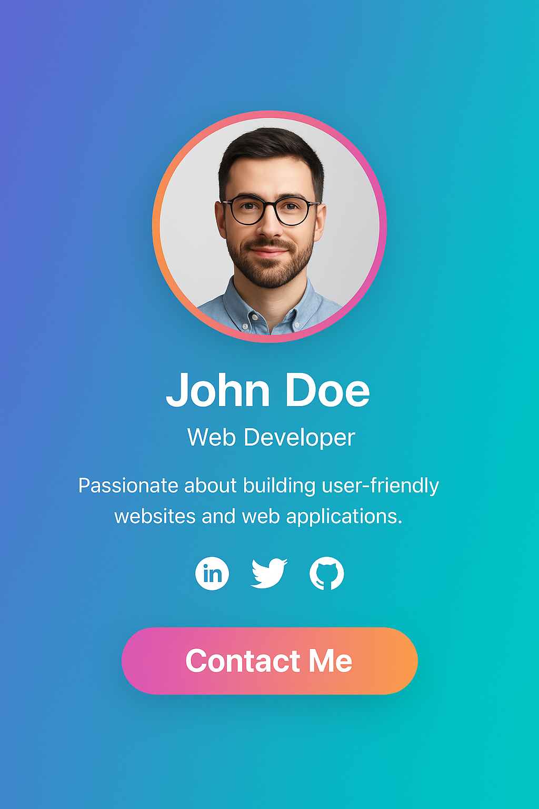

Task2:

Task2-Desktop and Task-Mobile pdf are attached